

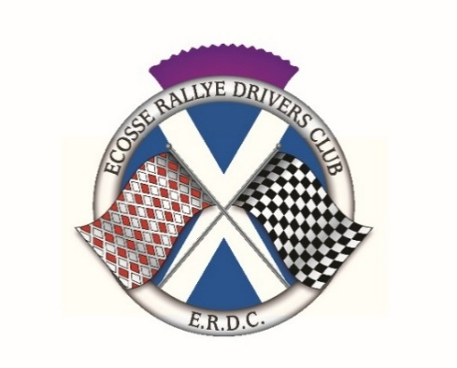

Saturday 30 May 2026
Lombard Rally Festival – Drumlanrig Castle
Scenic Tour

ENTRY FORM
Driver |  |  |  | Navigator
Name |  |  |  | Name
Address |  |  |  | Address
Postcode |  |  |  | Postcode
Telephone |  |  |  | Telephone
Mobile |  |  |  | Mobile
E-mail |  |  |  | E-mail
Age if under 18 |  |  |  | Age if under18
Driver’s next of kin |  |  | Navigator’s next of kin
Name |  |  | Name
Address |  |  | Address
Telephone/Mobile |  |  | Telephone/Mobile
Vehicle details
Make/model |  |  |  |  | Year |  | Reg No
Optional Static Show Entry - Sunday 31 May 2026 |  | Yes / No
Entry Fee
The entry fee for the event is £65 for club members or £75 for non-members. (includes a meal for 2 on 30 May 2026 at Drumlanrig)

Completed and signed Entry Forms to be emailed to Alan Brisbane alan.brisbane1@hotmail.com

The entry fee should be transferred to the ERDC bank account
Account name: Ecosse Rallye Drivers Club
Santander Bank; Sort Code 09 01 29
Account number 38813548

Declaration
I declare that: 1) I have been given the opportunity to read the General Regulations of Motorsport UK and, if any, the Supplementary Regulations for this event and agree to be bound by them. I declare that I am physically and mentally fit to take part in the event and I am competent to do so. I acknowledge that I understand the nature and type of competition and the potential risk inherent with motor sport and agree to accept that risk. I understand that motor sport can be dangerous and accidents causing death, injury, disability and property damage can and do happen. I understand that these risks may give rise to my suffering personal injury or other loss and I acknowledge and accept these risks. 2) To the best of my belief the driver(s) possess(es) the standard of competence necessary for an event of the type to which this entry relates and that the vehicle entered is suitable and roadworthy for the event having regard to the course and the speeds which will be reached. The use of the vehicle hereby entered will be covered by insurance as required by the law which is valid for such part of this event as shall take place on roads as defined by the law. 3) I understand that should I at the time of this event be suffering from any disability whether permanent or temporary which is likely to affect prejudicially my normal control of the vehicle, I may not take part unless I have declared such disability to Motorsport UK which has, following such declaration, issued a licence which permits me to do so. I undertake that at the time of the event to which this entry relates I shall have passed or am exempt from an ASN specified medical examination within the specified period. (H10.1.6) 4) Any application form for a Licence which was signed by a person under the age of 18 years was countersigned by that person’s parent/legal guardian/guarantor, whose full names and addresses have been given. 5) If I am the Parent/Guardian/Guarantor of the driver I understand that I shall have the right to be present during any procedure being carried out under the Supplementary Regulations issued for this event and the General Regulations of Motorsport UK. As the Parent/Guardian/Guarantor I confirm that I have acquainted myself and the minor with the Motorsport UK General Regulations, agree to pay any appropriate charges and fees pursuant to those Regulations (to include any appendices thereto) and hereby agree to be bound by those Regulations and submit myself without reserve to the consequences resulting from those Regulations (and any subsequent alteration thereof). Further, I agree to pay as liquidated damages any fines imposed upon me up to the maxima set out in Part 3, Appendix 1. Note: Where the Parent/Guardian/Guarantor is not present there must be a Guardian who must produce a written and signed authorisation to so act from the Parent/Guardian/Guarantor as appropriate. 6) I hereby agree to abide by the Motorsport UK Safeguarding Policy and Guidelines and the National Sporting Code of Conduct. 7) I have read and fully understood the regulations for Control of Drugs and Alcohol as contained in the Competitors’ and Officials Yearbook Regulations H39, D35.1, G15.1.4 and have also fully familiarised myself with the information on the web sites referred to (www.motorsportuk.org, www.ukad.org.uk and www.wada-ama.org) in particular the UK Anti Doping Rules which have been adopted by Motorsport UK. Further, if I am counter-signing as the parent or Guardian of a minor then in addition to the deemed consent to the testing of that minor (UK Anti-Doping Rule 5.7.2) I hereby confirm that I give such consent for the minor concerned to be so tested. 8) I understand that my personal data is being processed solely for the purposes of running this event and will be handled by the organisers in accordance with Motorsport UK data protection policy which can be found at www.motorsportuk.org/data-protection. Indemnity: In consideration of the acceptance of this entry I agree that neither any one of or any combination of Motorsport UK and its associated clubs, the organisers, the track owners or other occupiers, the promoters and their respective officers, servants, representatives and agents (the “Parties”) shall have any liability for loss or damage which may be sustained or incurred by me as a result of participation in the Event including but not limited to damage to property, economic loss, consequential loss or financial loss howsoever caused. Nothing in this clause is intended to or shall be deemed to exclude or limit liability for death or personal injury. To the fullest extent permitted by law I agree to indemnify and hold harmless each of the Parties in respect of any loss or damage whatsoever and howsoever arising from my participation in this event.

I confirm that I have read and agree to the terms of the Declaration
Signature of Driver |  |  | Age if  under 18 |  |  | Date
Signature of Navigator |  |  | Age if  under 18 |  |  | Date
Consent of Parent or Guardian if Driver and/or Navigator is under 18 years of age.
Parent/Guardian of Driver |  |  | Parent/Guardian of Navigator
Name |  |  | Name
Address |  |  | Address
Relationship |  |  | Relationship
Contact No. |  |  | Contact No.
Signature |  |  | Signature

Data Protection Act: Prospective entrants and competitors are advised that information supplied on the entry form will be held on a computer and used for the administration of the event but will not be passed on to a third party.

