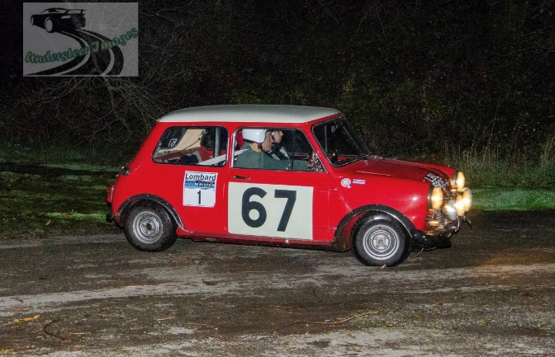
LOMBARD RALLY BATH 2023 THE UK’S First and Premier Historic Rally Tour with Special Stages. 27th and 28th October 2023
For the sixth time, we look forward to welcoming you to the event, ‘Friday in the Dark’ returning and Saturday route, running south through Somerset, to Devon. We will return to a well known hillclimb venue, as used on the Lombard RAC Rally in the past, plus other past special stages venues no longer available on competitive events.
The Friday formalities will take place at Bath Racecourse, as they did pre-COVID with a short run out to two tarmac stages, run in the dark. One of these will be at Hengrove Park in Bristol, which will be tackled twice. This will be followed by a Meet and Greet back at the Racecourse with a light meal.
The Saturday route will depart from the Racecourse. The route will run south into Somerset onto the Mendips, before reaching three tarmac stages. Into Devon for two more stages, with lunch also taken near there. After a second hillclimb visit, another stage, the route will return north again to finish at Bath Racecourse. There will be in all twelve stages, before returning to the Racecourse in the evening, where the cars will be parked overnight. The Sunday run has been replaced by ‘Friday in the Dark’.
The Saturday evening dinner will take place at the Racecourse, a less formal dinner than those in the past in Bath. This will mean that those people concerned with the Clean Air Zone will not need to go into the City of Bath itself. We will return to having a guest speaker at the Saturday evening dinner, who will be confirmed in due course.
A limited number of guest places will also be available at the Rally Dinner.
We look forward to again welcoming you to the longest established and premier rally revival demonstration event held in the UK. AS PER IOPD Rulings, HANS devices and Balaclavas are not required for Historic Rally Cars to take part in a Demonstration event. You are free to use if you wish. Cars not complying with current stage rally rules are welcome, such as Targa or Road Rally cars, or cars complying with older rally car regulations, please simply advise the organisers of your car. If its basic model is less than 25 years old, please contact the organisers also. Helmets will be needed on the demonstration stages, but HANS devices and overalls will be at entrants’ discretion.
We apologise that we have had to increase entry costs in 2023 to reflect the fact that Hospitality and Catering costs have rocketed – we got caught out by last minute increases in 2022. COVID-19 Precautions we hope are over:
Entry Costs for both Friday in the Dark and Saturday including the Friday Evening Buffet, Saturday Lunch and Dinner, for a crew of two, entry and full payment by March 31st 2023 £570.00
As above, but entry and full payment by July 31st 2023 £610.00
Entries after 31st July at £625.00 with payment due in full.
Saturday Run only with no social events or ‘Friday in the Dark’ £460.00 payment required in full with this selection.
Hotel packages:
Limpley Stoke Hotel, Woods Hill, Limpley Stoke, Bath BA2 7FZ which is a 3 star hotel. Twin or Single Room £220.00
Bailbrook House Hotel, a 4 star Hotel from the Hand Picked collection, Eveleigh Avenue, London Road West, Bath BA1 7JD. Twin or Double Room £490..00
Both of the hotels can be reached without entering the Bath Clean Air Zone and consequent costs. The quoted costs are for both nights, bed and breakfast.

A non-returnable deposit payment of £100.00 before 31st July will be required to reserve your entry, afterwards payment in full. Please add a 25.00% deposit, per room, for the Hotel selected.

Rally car hire is again available from £1350.00 for an ex-works MG Maestro, or a Ford KA. A Mark 2 Escort is available from £1500.00…
NOTE - Trailer Parking is available at the start venue for both Friday and Saturday evenings. Motorhome Parking will also be available.
Entry and Hotel Booking:

Driver 1 Name…………………………………………………Telephone Number…………………..
Address……………………………………………………………………………………………………………..
………………………………………………………………..Email………………………………………………..
Driver 2 Name…………………………………………………Car……………………………………………
Please select:
Friday dinner, ‘Friday in the Dark’, Saturday Entry and Dinner £610.00………..….. if after 31/3/23, with payment in full by 31/7/23
After 31st July at £625.00 with full payment with entry……………………………………..
Saturday Run only, no Social Events or ‘Friday in the Dark’ £460.00…………………
I will want to bring………...guests to the Saturday Dinner at a cost of £45.00 per person - all dinners and lunches are included for drivers one and two
I will want to use a Hire Car, please contact me to discuss……………….
Hotel Package:
Limpley Stoke Hotel …..…….….Rooms @ £220.00
Bailbrook House Hotel……………Tooms @ £490.00.
Balance of the hotel cost one month before the event.
Organised by TN Motorsport, 39 Fairway, Bristol BS4 5DF, UK Telephone(44)07591212391 email: tim@lombardrallybath.co.uk web: www.lombardrallybath.co.uk
Please pay by transfer to Lloyds Bank Sort Code 30=00=01, Account No. 07857368 Account Name Tim Nash, BIC: LOYDGB21017 IBAN: GB87 LOYD 3000 0107 8573 68

